- Create virtual environment = python -m venv venv
- Activate vm = venv\Scripts\Activate
- Install reflex = pip install reflex
- Initialize reflex = reflex init
- https://reflex.dev/docs/recipes/
In this reflex docs under recipes we can get a code for layout, content, login form and others.

- Basic index function with style properties
- import reflex as rx

- def index():
- return rx.text('This is a home page', font_size='20px', bg="green", color='red',
- font_weight="bold", _hover={'color':'white', 'bg':'black', 'font_size': '30px'})

- app = rx.App()
- app.add_page(index)
- # app._compile()

7. Run in terminal by write (reflex run)
8. This app._compile() is optional, in previous versions of reflex it used but now when you press the ctrl+S, your code will be compiled and you can see the output.

9. Suppose you have a lot of items that you cannot add to the home page. In that case, you can create a new function for them and then add that function using the add_page() function, where you assign a route for that page.

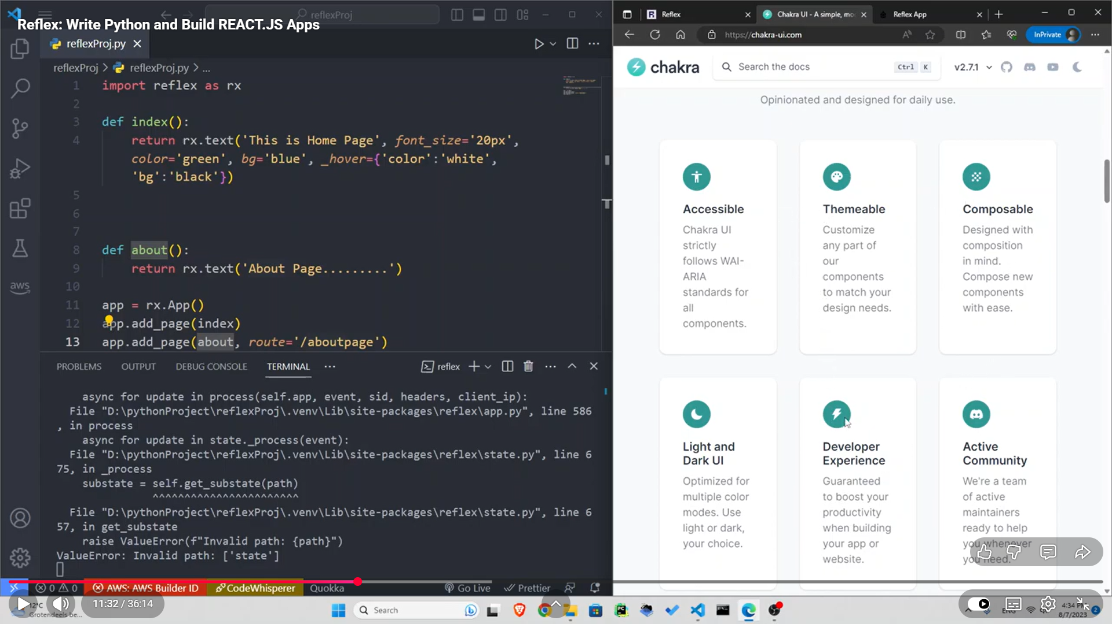

10. As shown in the above image, a new about function was created and then added as a page using the add_page() function.

11. Navbar we will write now
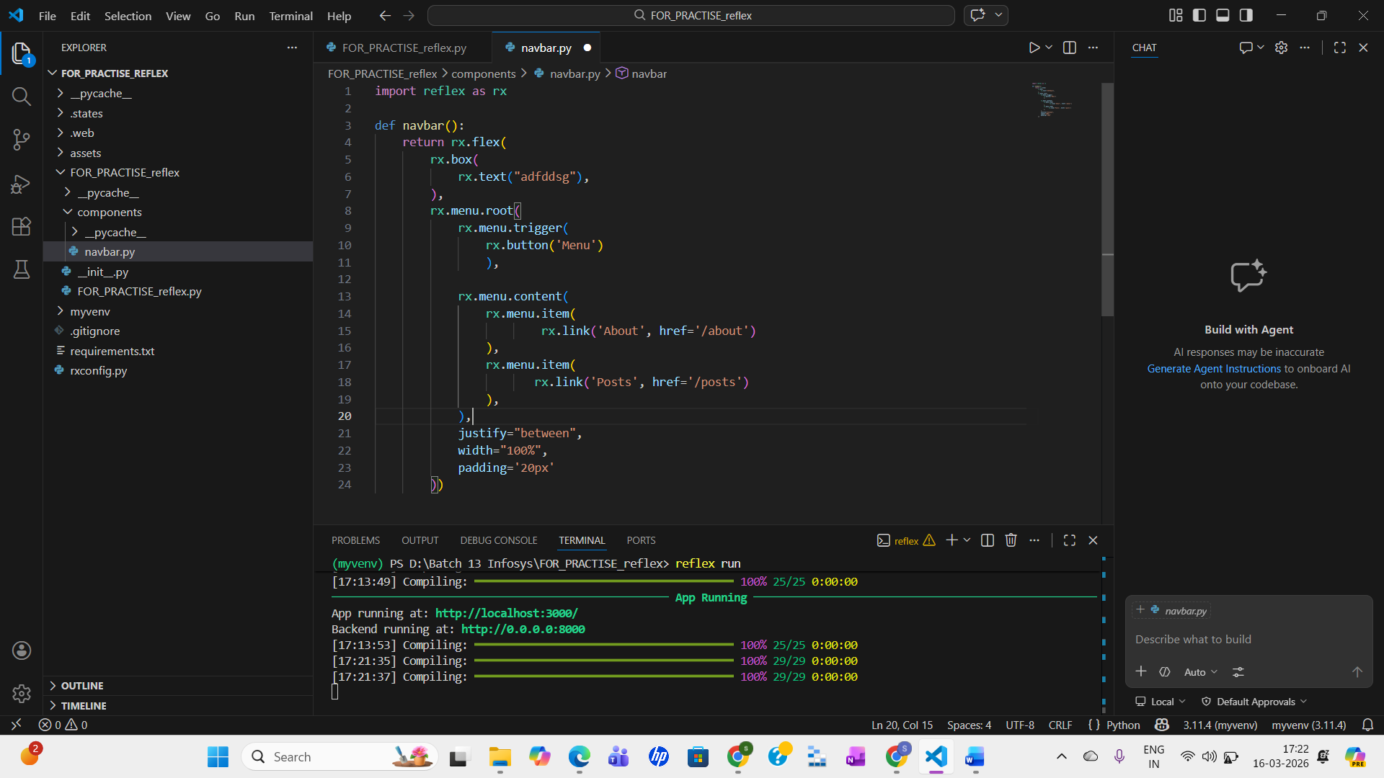

12. In the main file, we will connect this

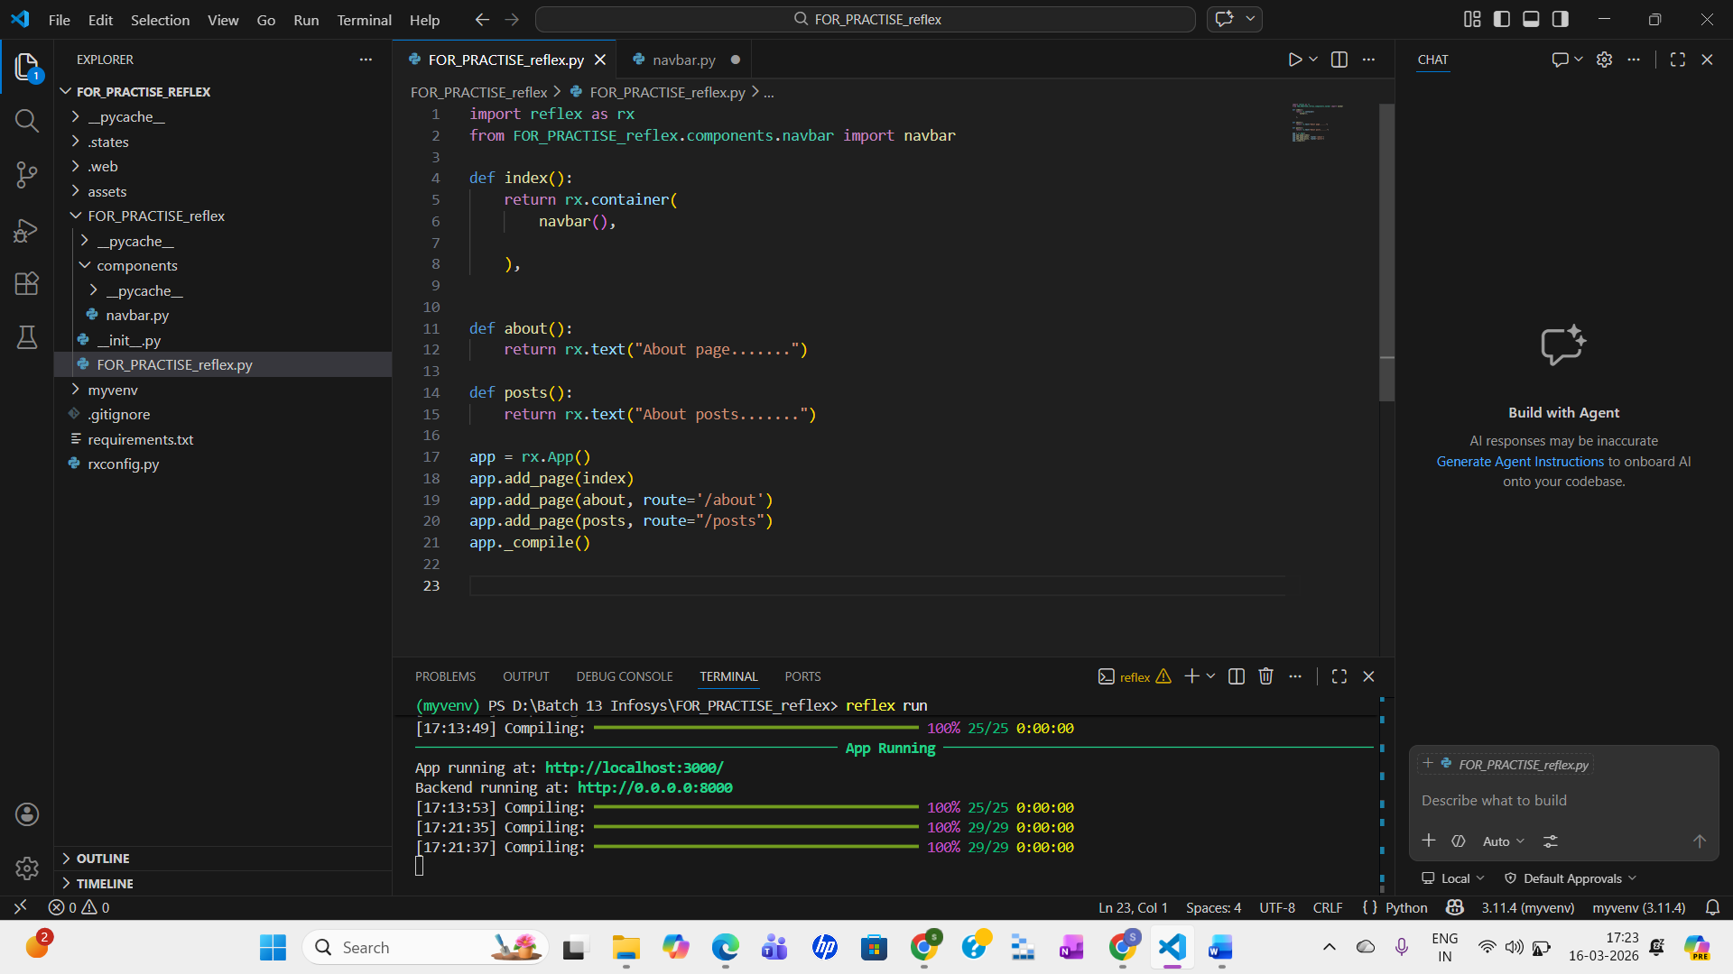

13. if I want to make sure, that if someone will click on the logo (suppose added image), we will redirect them on the home page so for that in the navbar inside the box I will add a rx.link and inside that I will add the rx.image and route (‘/’)

def navbar():
return rx.flex(
rx.box(
rx.link(
rx.image(src='Chat bot-rafiki.png',
width='100px', align="left"), href='/')
),

And then inside the about and post page, I will add what the home page is returning

def about():
return rx.container(
navbar(),
rx.text('About app.....'))

def posts():
return rx.container(
navbar(),
rx.text('About posts....'))

14. This rx.container contains the content to a certain limit and it adds margins to right and left. So, as in a container we have added the navbar, text and we can add button as well or things like that.
- Now to add a subtle line after the navbar, we can use rx.divider, here:
- def index():
- return rx.container(
- navbar(),
- rx.divider(),
- rx.text('THis is a home page')
- )

- Now, let’s create kind of a grid here after the navbar, so that we will have a two items here, so that when the screen is medium size or larger, I’m gonna have two sections in one row and when the screen is smaller I will have only one column basically, so I’m gonna create another component inside our components folder with the name of header.py

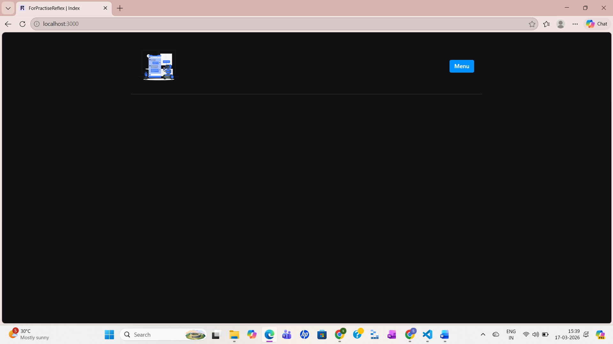
- So, in the header.py file we have written this code but still it does not have a feature to change the images layout by changing the screen size
- import reflex as rx

- def header():
- return rx.grid(
- rx.center(
- rx.box(
- rx.heading('I am Simran!'),
- rx.heading('This project is about.....,'),
- rx.button('Click here!')

- )
- ),
- rx.center(
- rx.image(src='Chat bot-rafiki.png')
- )
- )

18. So, here to specify that we need to columns on medium and bigger size and one column on smaller size. So we will going to add new props “columns”={}, right after the 2 columns inside the rx.grid only. This columns is a dict, it says that on the smaller screen go with one column.
def header():
return rx.grid(
rx.center(
rx.box(
rx.heading('I am Simran!'),
rx.heading('This project is about.....,'),
rx.button('Click here!')

)
),
rx.center(
rx.image(src='Chat bot-rafiki.png')
),
columns={
"base": "1",
"md": "2",
"lg": "3"
}
)

